Week1 Assignment
Kalpana Renjarla
CT5150 Data Science Tools – CRN196
Perkins
New England College
07-19-2026

Assignment Overview
This document numbers the responses for the required Chapter 5 sections and answers each exercise posed within those sections. The accompanying knitted HTML contains the complete commented R code and generated output. The assigned sections do not create graphs, so graph interpretation is not applicable.
1. Section 5.1 — Atomic Vectors
Response: An atomic vector is a one-dimensional R object whose elements share one data type. The replicated code creates and inspects double, integer, character, logical, complex, and raw vectors using c(), typeof(), is.vector(), length(), and related operations.
die <- c(1, 2, 3, 4, 5, 6)
is.vector(die)
typeof(die)
Exercise 5.1 — Character or Number?
Question: Which of 1, "1", and "one" are character strings, and which are numbers?
Answer: 1 is numeric. "1" and "one" are character strings because values enclosed in quotation marks are stored as character data.
typeof(1)
typeof("1")
typeof("one")
Exercise 5.2 — Vector of Cards
Question: Create an atomic vector containing the royal-flush face names and identify the appropriate vector type.
Answer: A character vector is appropriate because card names are text labels.
hand <- c("ace", "king", "queen", "jack", "ten")
typeof(hand)
2. Section 5.3 — Matrices
Response: A matrix arranges one atomic vector in two dimensions. By default, matrix() fills values by columns; byrow = TRUE fills values by rows.
m <- matrix(die, nrow = 2)
m <- matrix(die, nrow = 2, byrow = TRUE)

Exercise 5.3 — Make a Matrix
Question: Create a five-row, two-column matrix containing the face and suit of every card in a spade royal flush.
Answer: A ten-element character vector can be reshaped by specifying five rows, two columns, or a 5-by-2 dimension. If face and suit values alternate, the matrix must be filled by rows.
hand1 <- c("ace", "king", "queen", "jack", "ten",
"spades", "spades", "spades", "spades", "spades")
matrix(hand1, nrow = 5)
3. Section 5.4 — Arrays
Response: Arrays extend matrices to n dimensions. The replicated example creates a 2-by-2-by-3 array containing three numbered slices.
ar <- array(c(11:14, 21:24, 31:34), dim = c(2, 2, 3))
ar
Interpretation: Slice 1 contains values 11–14, slice 2 contains 21–24, and slice 3 contains 31–34. R fills each slice by columns.
4. Section 5.7 — Lists
Response: A list can combine R objects of different types and lengths, including nested lists. This flexibility avoids the single-type restriction of atomic vectors.
list1 <- list(100:130, "R", list(TRUE, FALSE))
list1
Exercise 5.5 — Use a List to Make a Card
Question: Store the face, suit, and point value of the ace of hearts in separate list elements.
Answer: The list preserves the face and suit as character values and the point value as a number.
card <- list("ace", "hearts", 1)
card
5. Section 5.8 — Data Frames
Response: A data frame is a two-dimensional list of equal-length vectors. Different columns may store different data types, making data frames appropriate for tabular analysis.
df <- data.frame(face = c("ace", "two", "six"),
suit = c("clubs", "clubs", "clubs"), value = c(1, 2, 3))
df
Interpretation: In the complete deck, each of the 52 rows represents one playing card. The face and suit columns contain character data, while value contains numeric point values.
6. R Markdown Execution and Timestamp Evidence
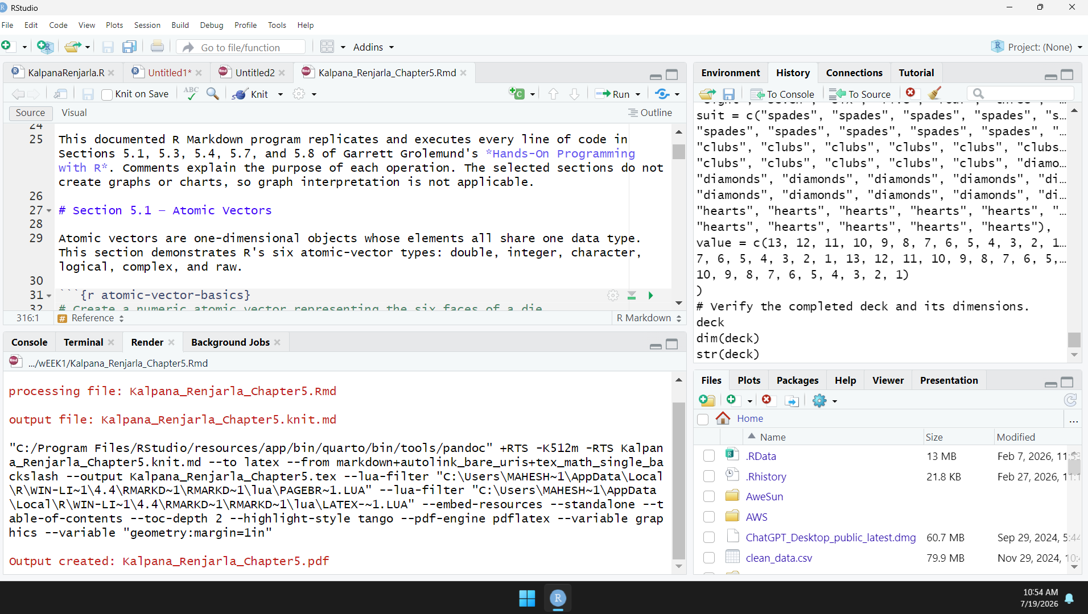
Conclusion
The completed work demonstrates how R progresses from single-type atomic vectors to matrices and arrays, then to flexible lists and analysis-ready data frames. All requested sections and exercises are documented in the accompanying R Markdown program, and the knitted output presents the code together with its generated results.
Reference
Grolemund, G. (2014). Hands-on programming with R. O'Reilly Media. https://rstudio-education.github.io/hopr/r-objects.html

